Lab 9 - Create and use Experience profiles
Introduction
In this lab, you will create and configure an Experience Profile in the Copilot Service workspace. Experience profiles help define the agent workspace settings, assign users, and enable productivity tools that support efficient service operations. You will create a new profile named Contoso Agent and assign a user to this profile to enable tailored agent experiences.

Task 1 - Create a New Experience Profile
In this task, you will access the Copilot Service admin center through the Power Platform admin center and create a new Experience Profile named Contoso Agent. You will define its name, unique identifier, and description to establish a workspace configuration for agents.
- Open a new tab in the browser. Sign in to the Power Platform admin center - !!https://admin.powerplatform.microsoft.com/!! with the credentials provided to execute the lab in the home tab. Select > Environments> ContactCenter Trial environment> Environment URL.
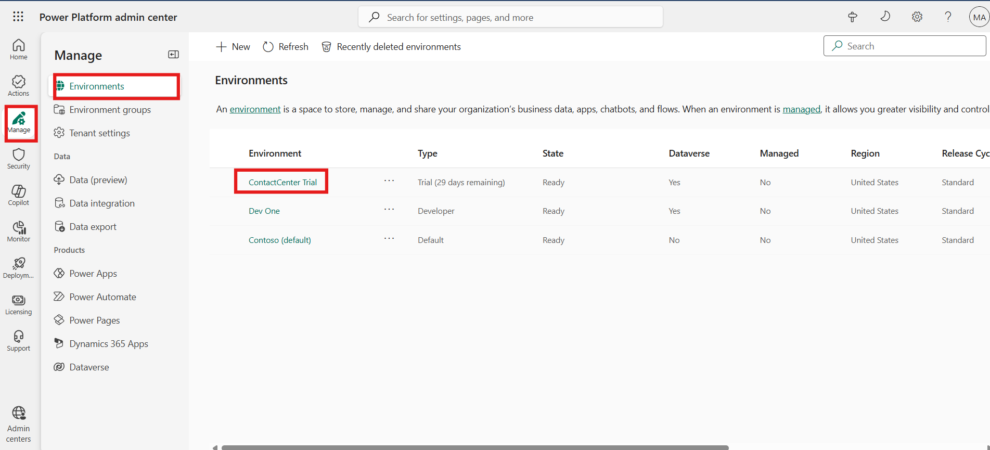
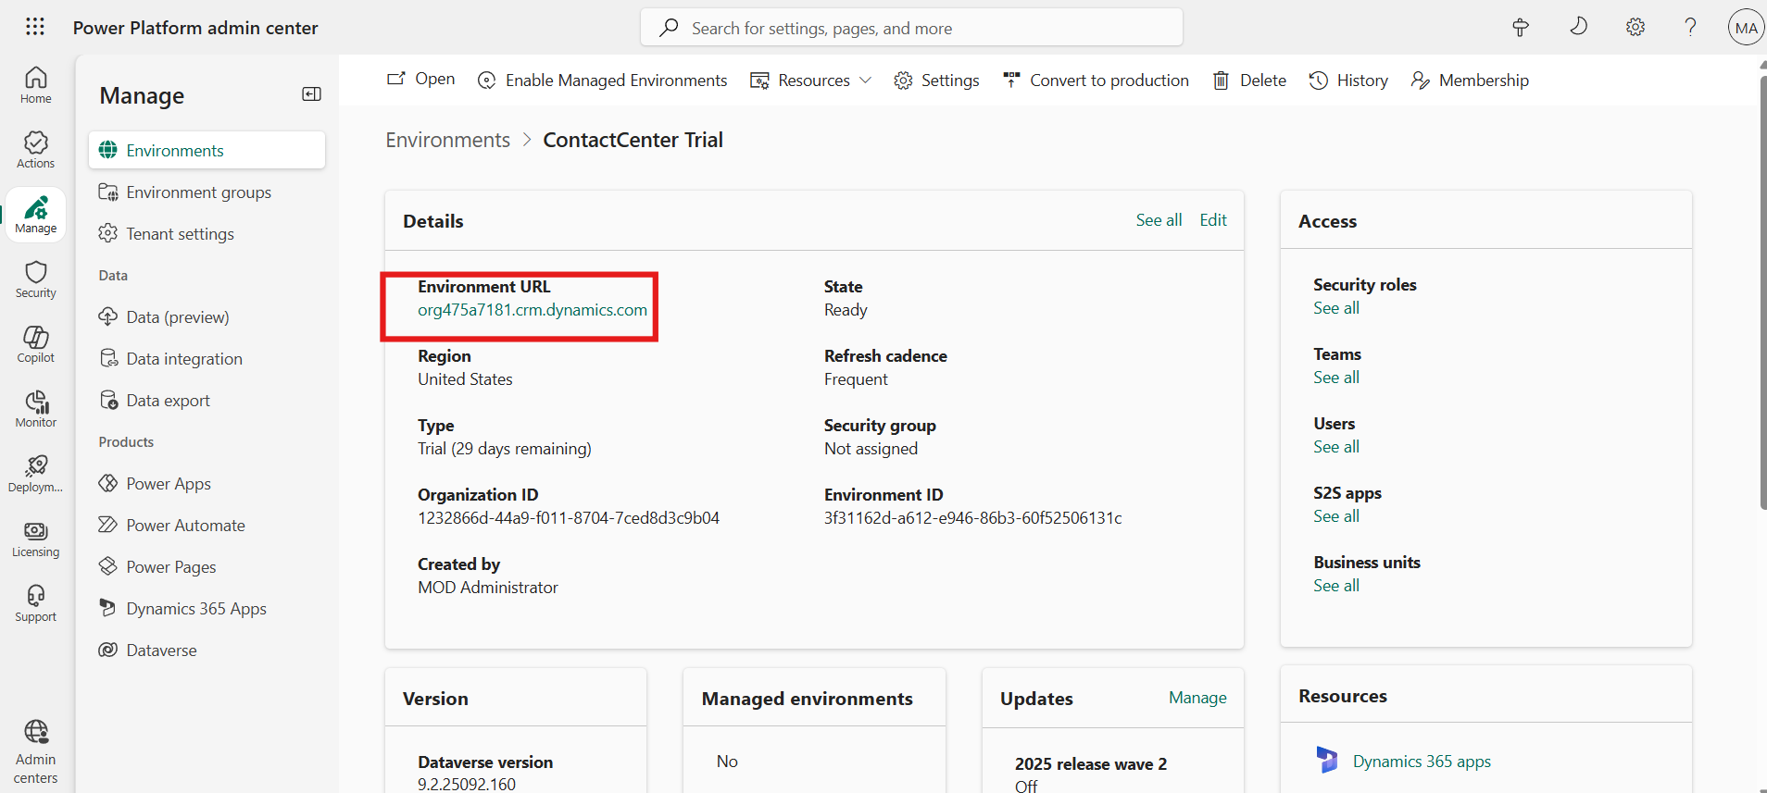

- You will be navigated to the Copilot Service admin center.
Note: If you do not navigate to the Copilot service admin center. Click on App selector from the top and then select the app.
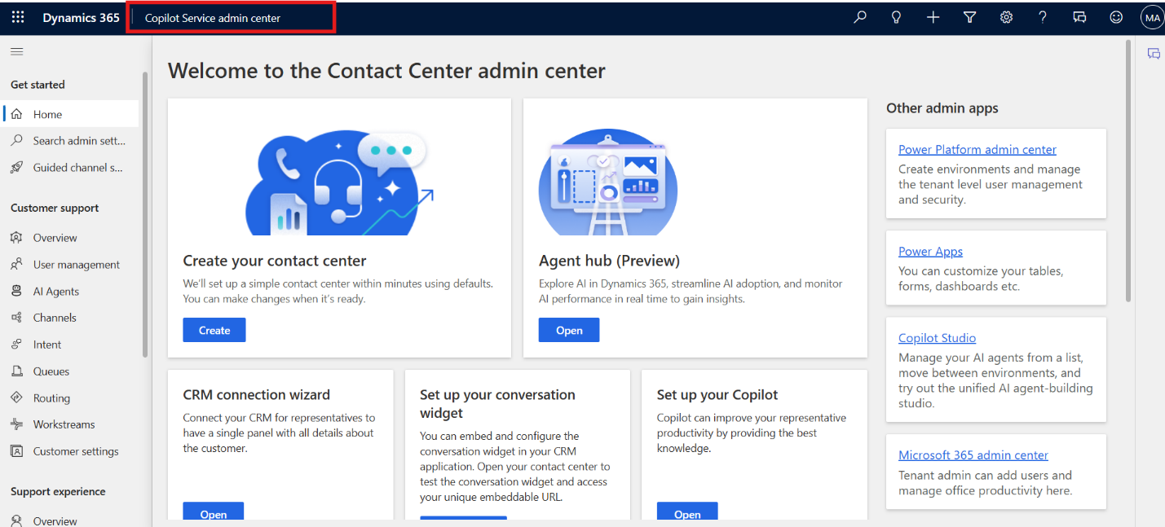
- Navigate to Workspaces under Support experience. In the Experience profile section click on the Manage option.
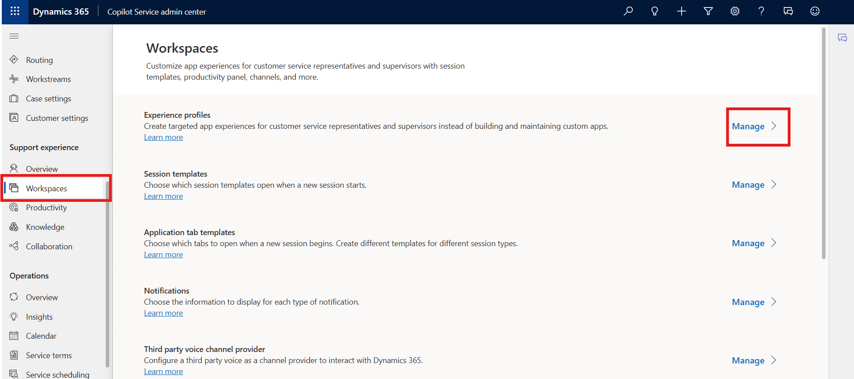
5. Click on the + new from top bar to create new experience profile.
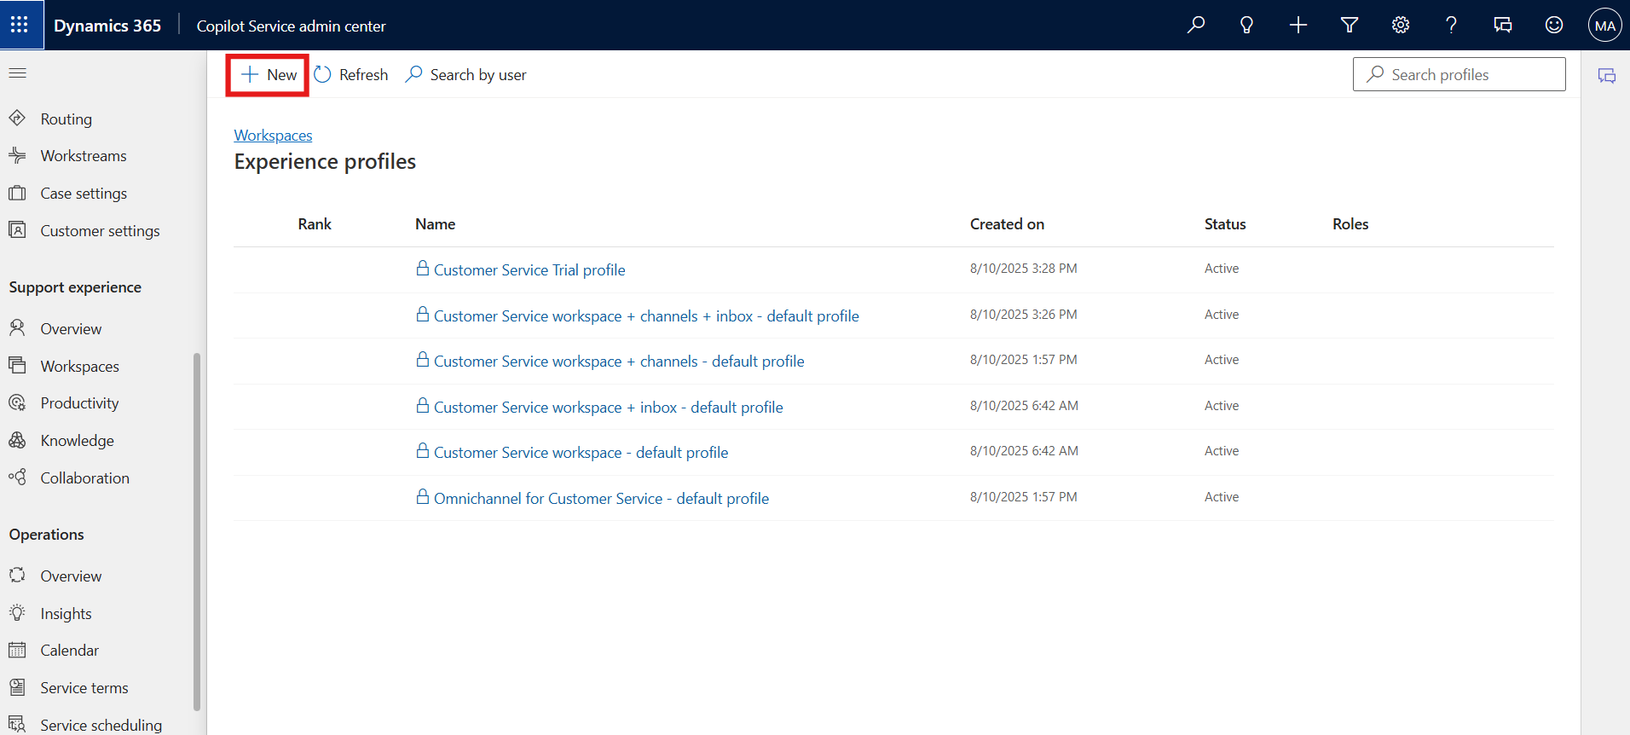

- Enter the following details on the Create a new experience profile dialog.
  - Name: !!Contoso Agent!!
  - Unique name: !!msdyn_custom_chatagent!!
  - Description: !!Contoso Agent!!
  - Select Create.
  - 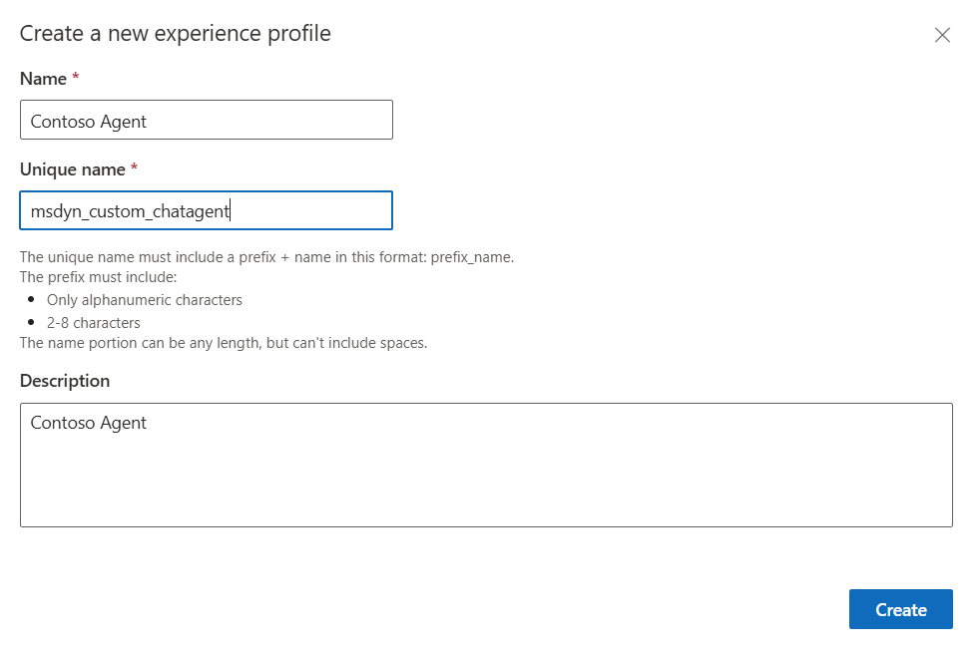
- An Experience profile is created.
- 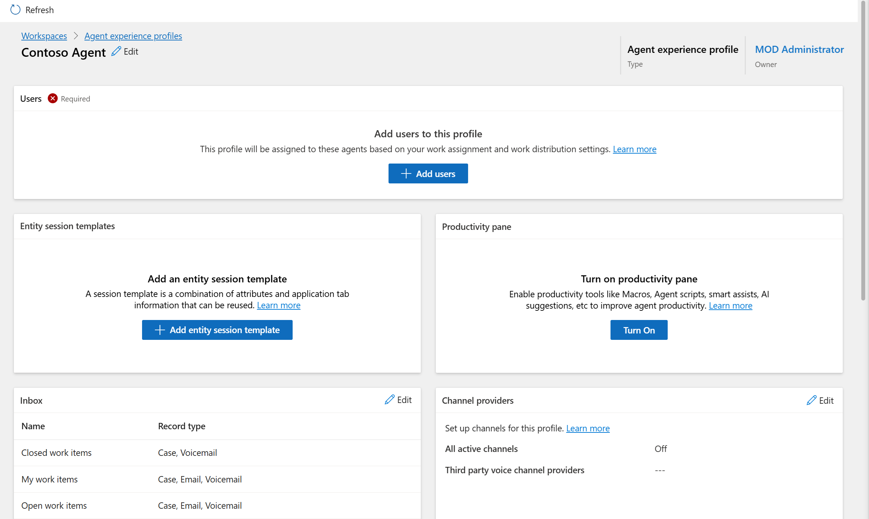

Task 2 - Add Users and Configure the Experience Profile
In this task, you will add a new user (Megan Bowen) to your environment, assign the necessary security roles, and link the user to the Contoso Agent Experience Profile. You will also associate a session template with the profile and enable productivity pane tools to optimize the agent’s workspace.
- Open a new tab in the browser. Sign in to the Power Platform admin center - !!https://admin.powerplatform.microsoft.com/!! with the credentials provided to execute the lab in the home tab.
- In the left side panel, select Environments.
- Select your CopilotService Trial environment.
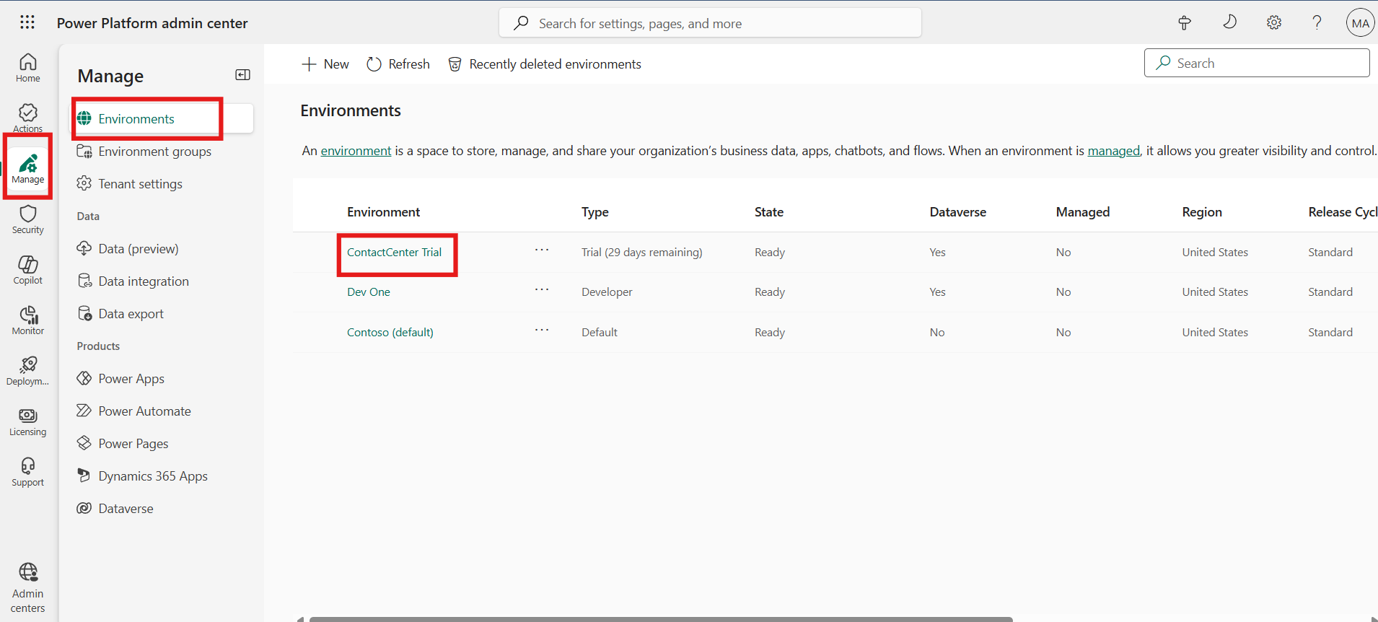
- Select Settings from the upper menu.
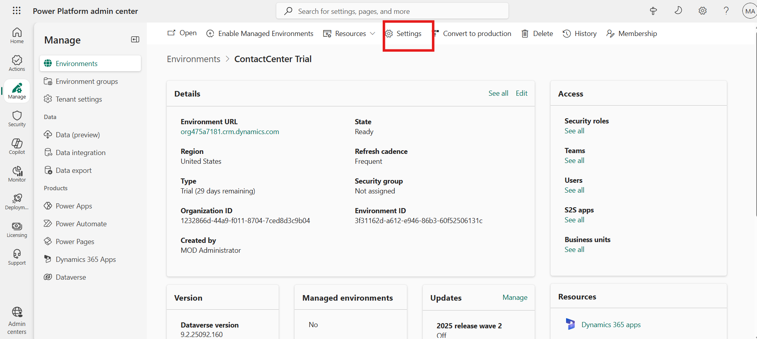
- Select Users + permissions to expand drop down and then click on the Users option.
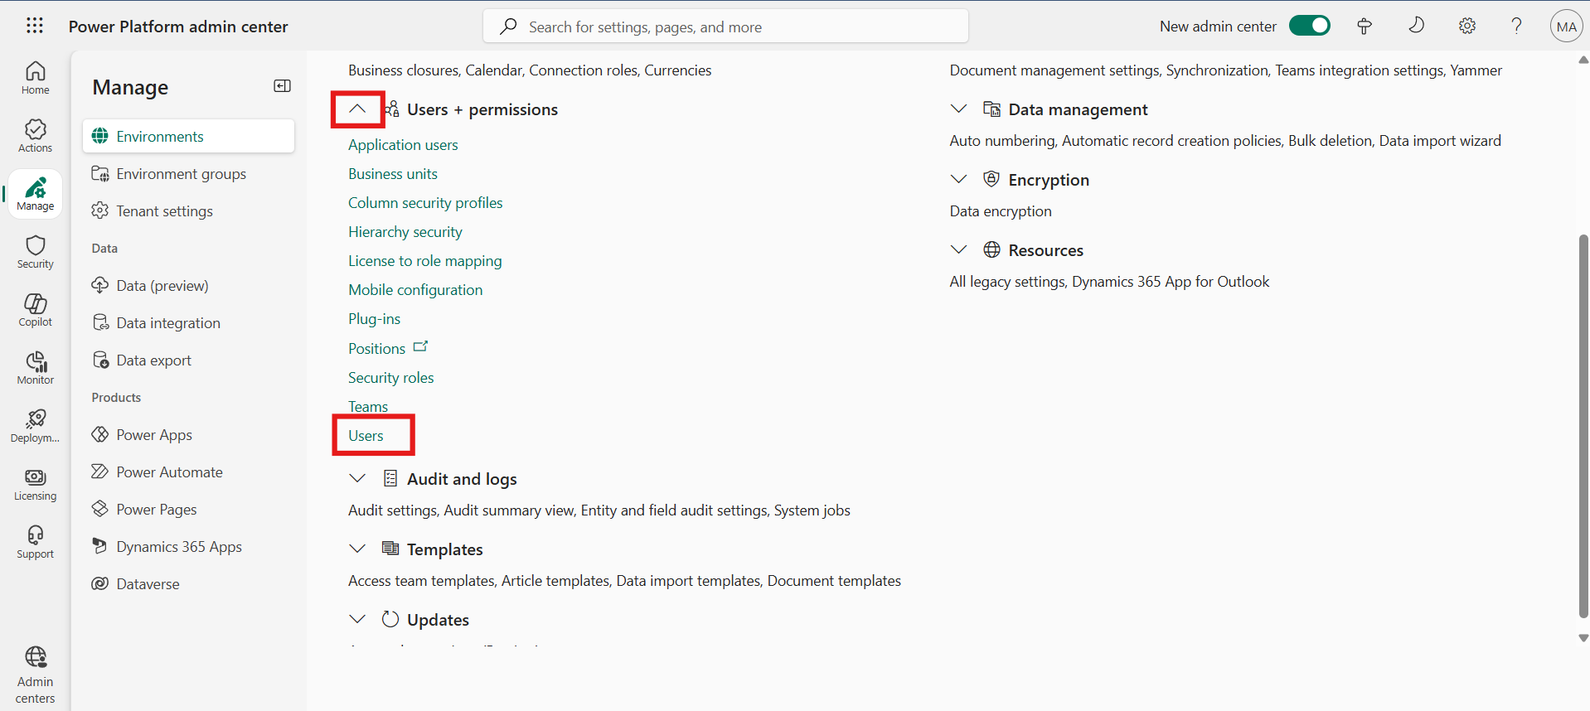
- From the upper menu, select Add user.

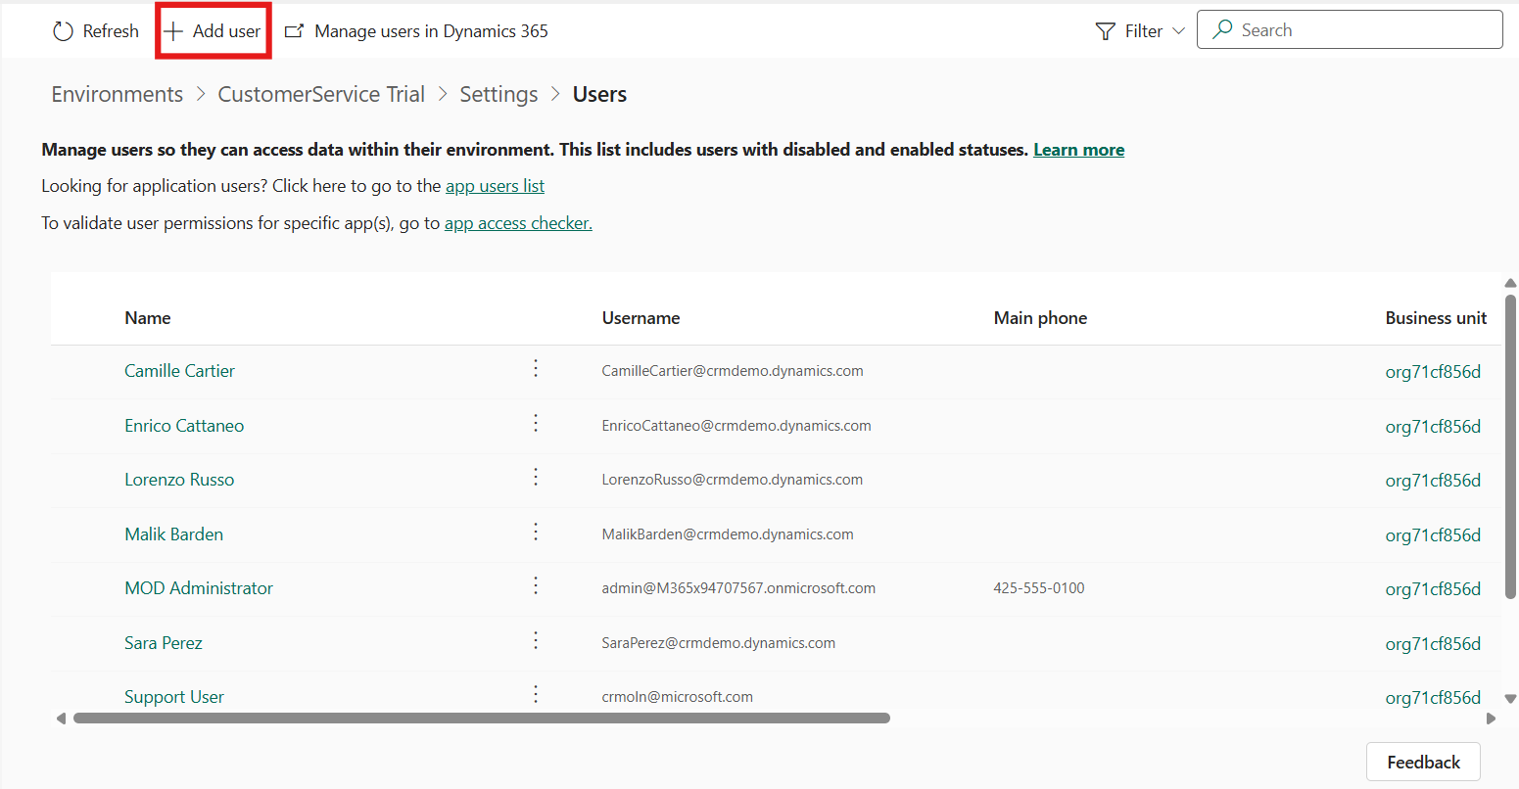
- In the Add user pane, search for and select Megan Bowen. Select Add.
- 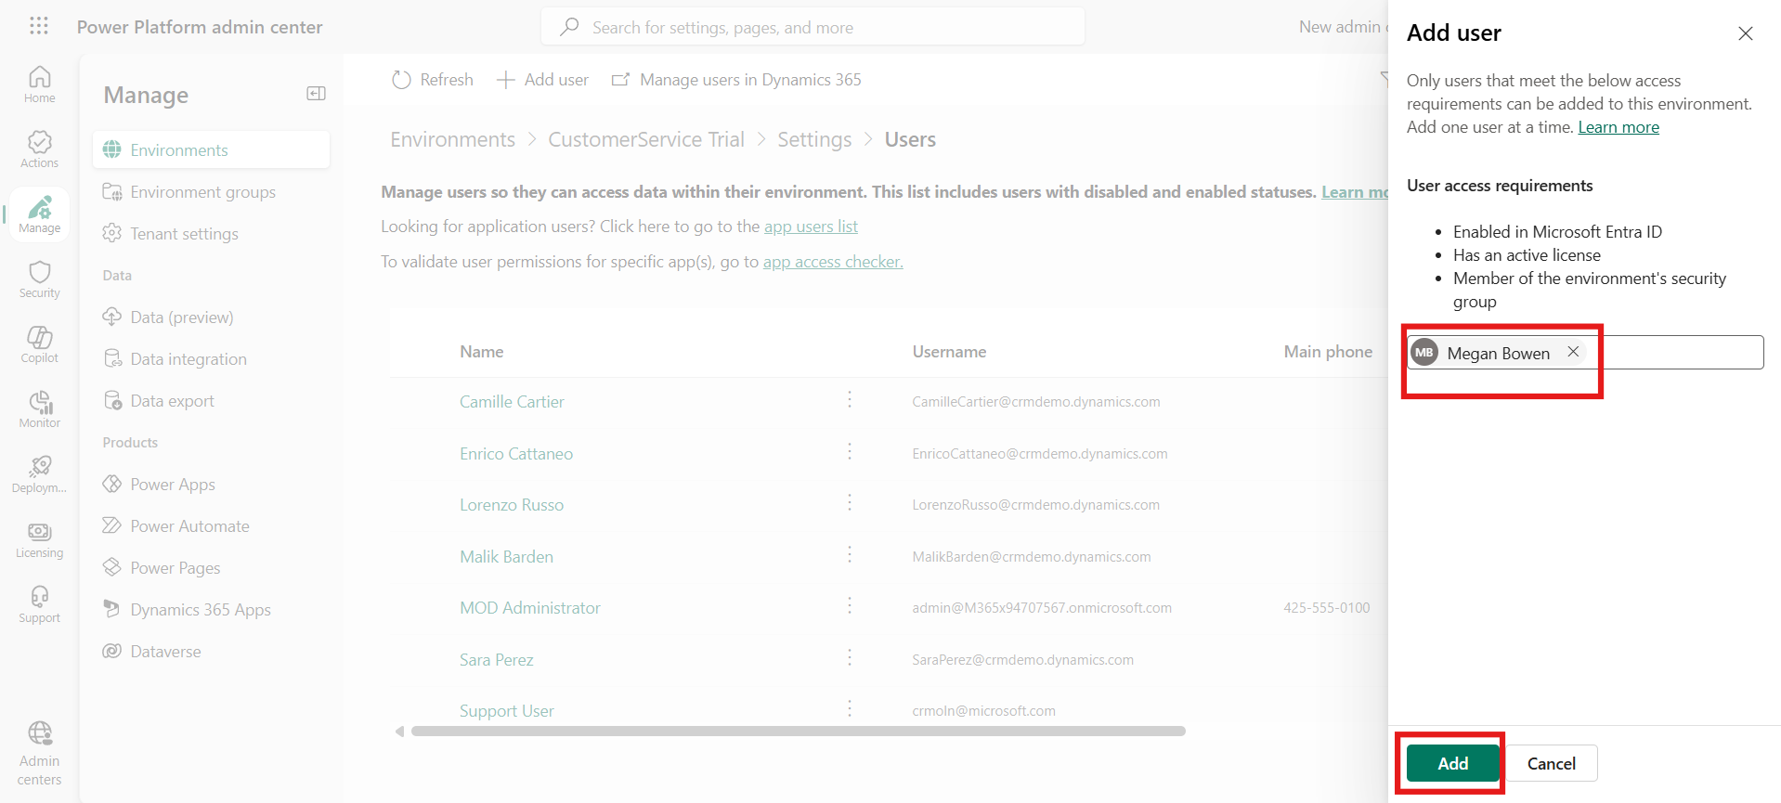
- In the Manage security roles page, select the System administrator role. Select Save.
- 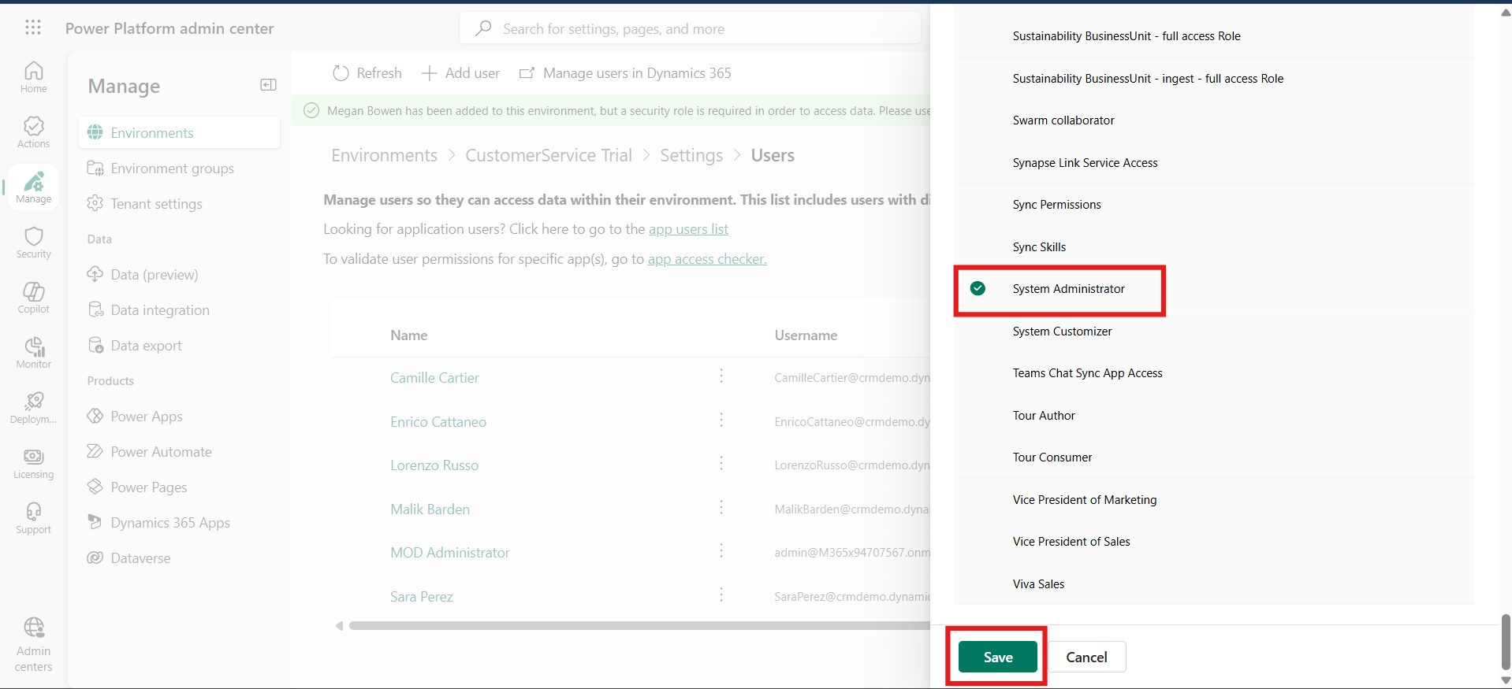
- Switch back to the Copilot Service admin center tab. Navigate to Support experience > Workspaces and then click on the Manage option in Experience Profile section.
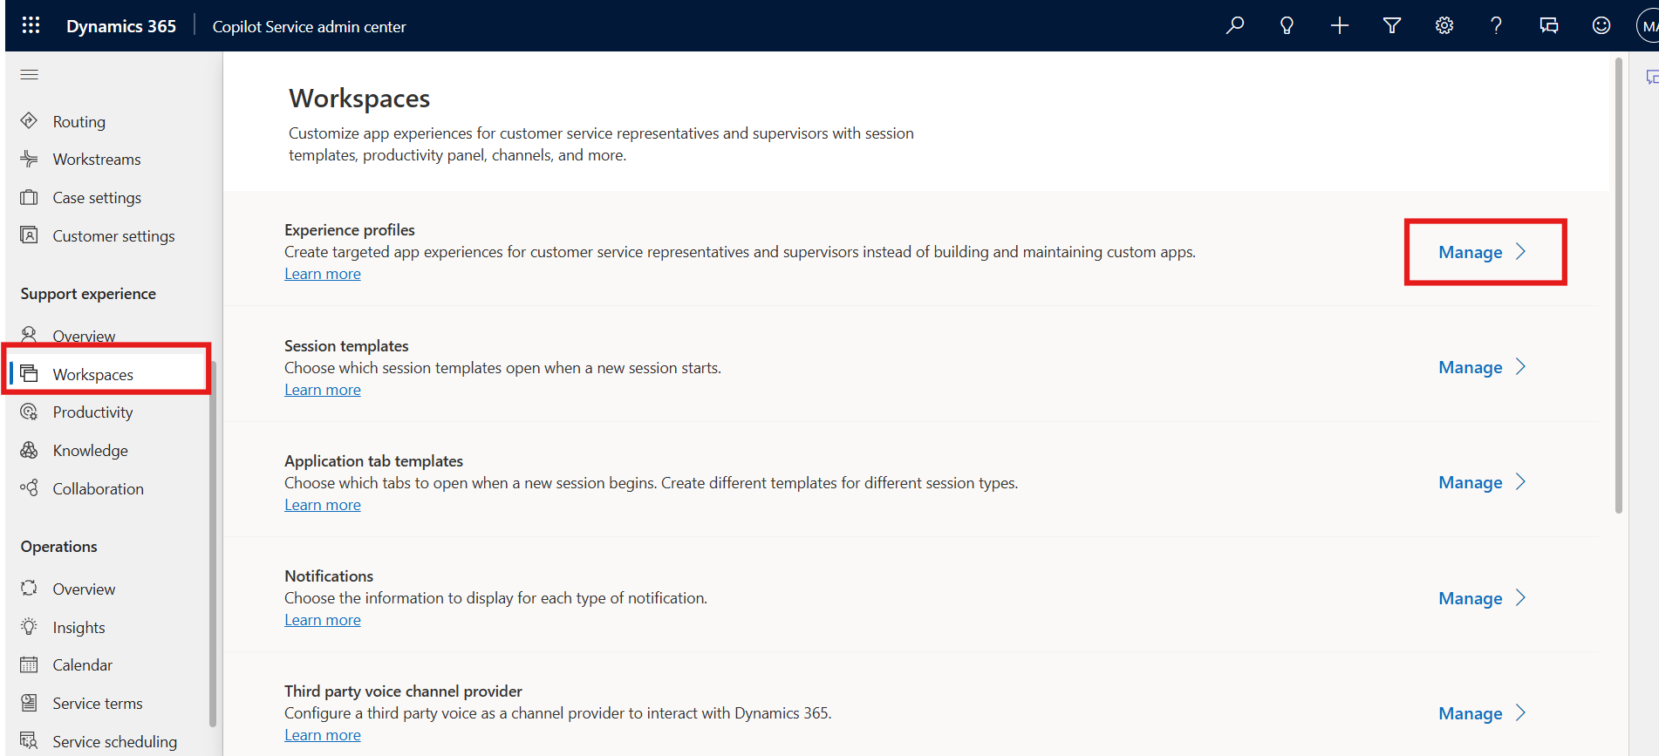
- Click on the Contoso Agent profile.
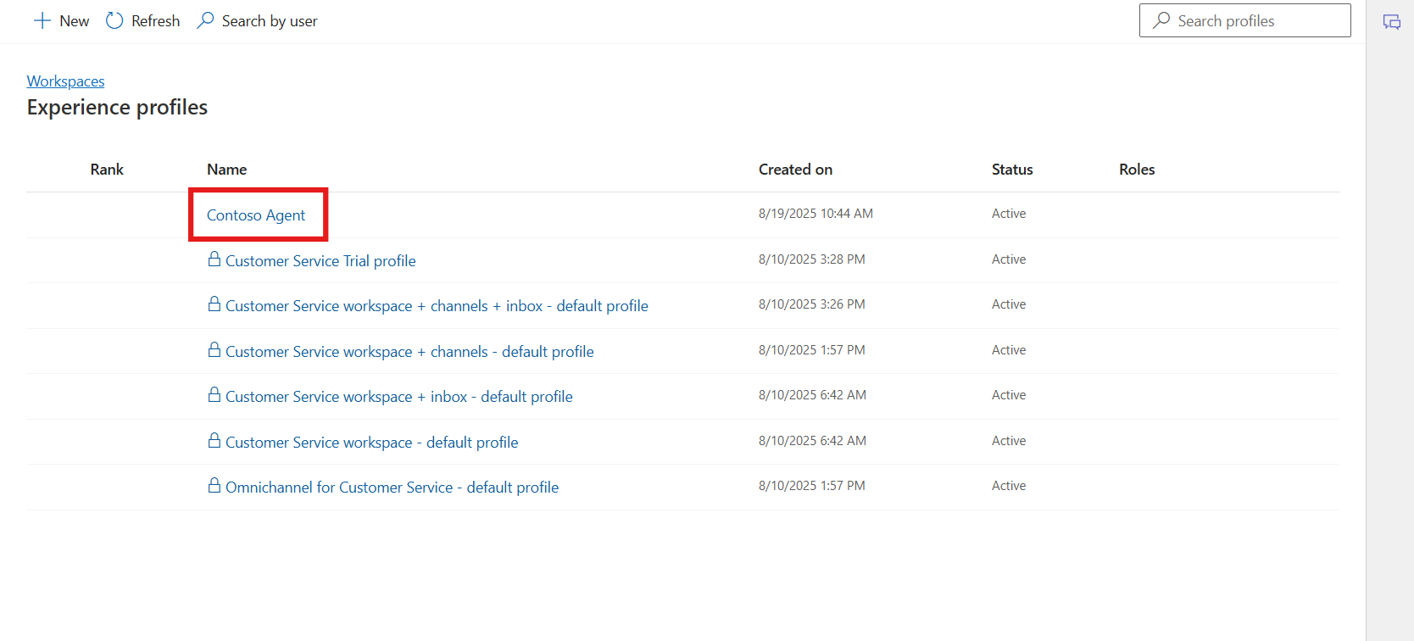
- In the Users section, specify the agents this profile must be associated with. Select Add Users.
- 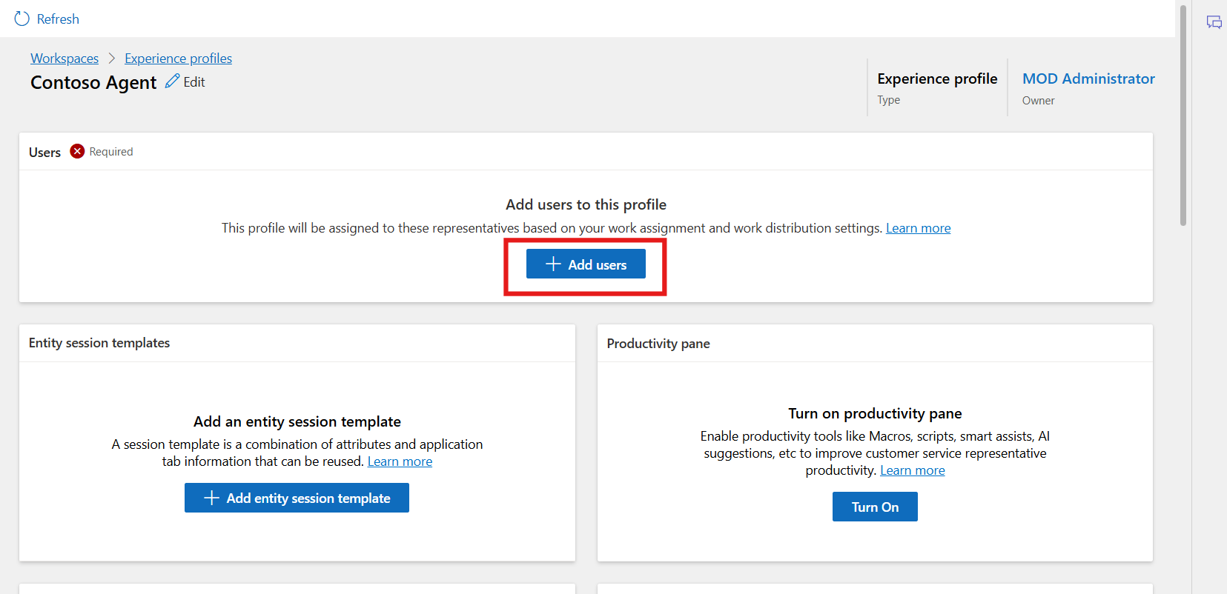
- Select the user Megan Bowen. Select Add.
- 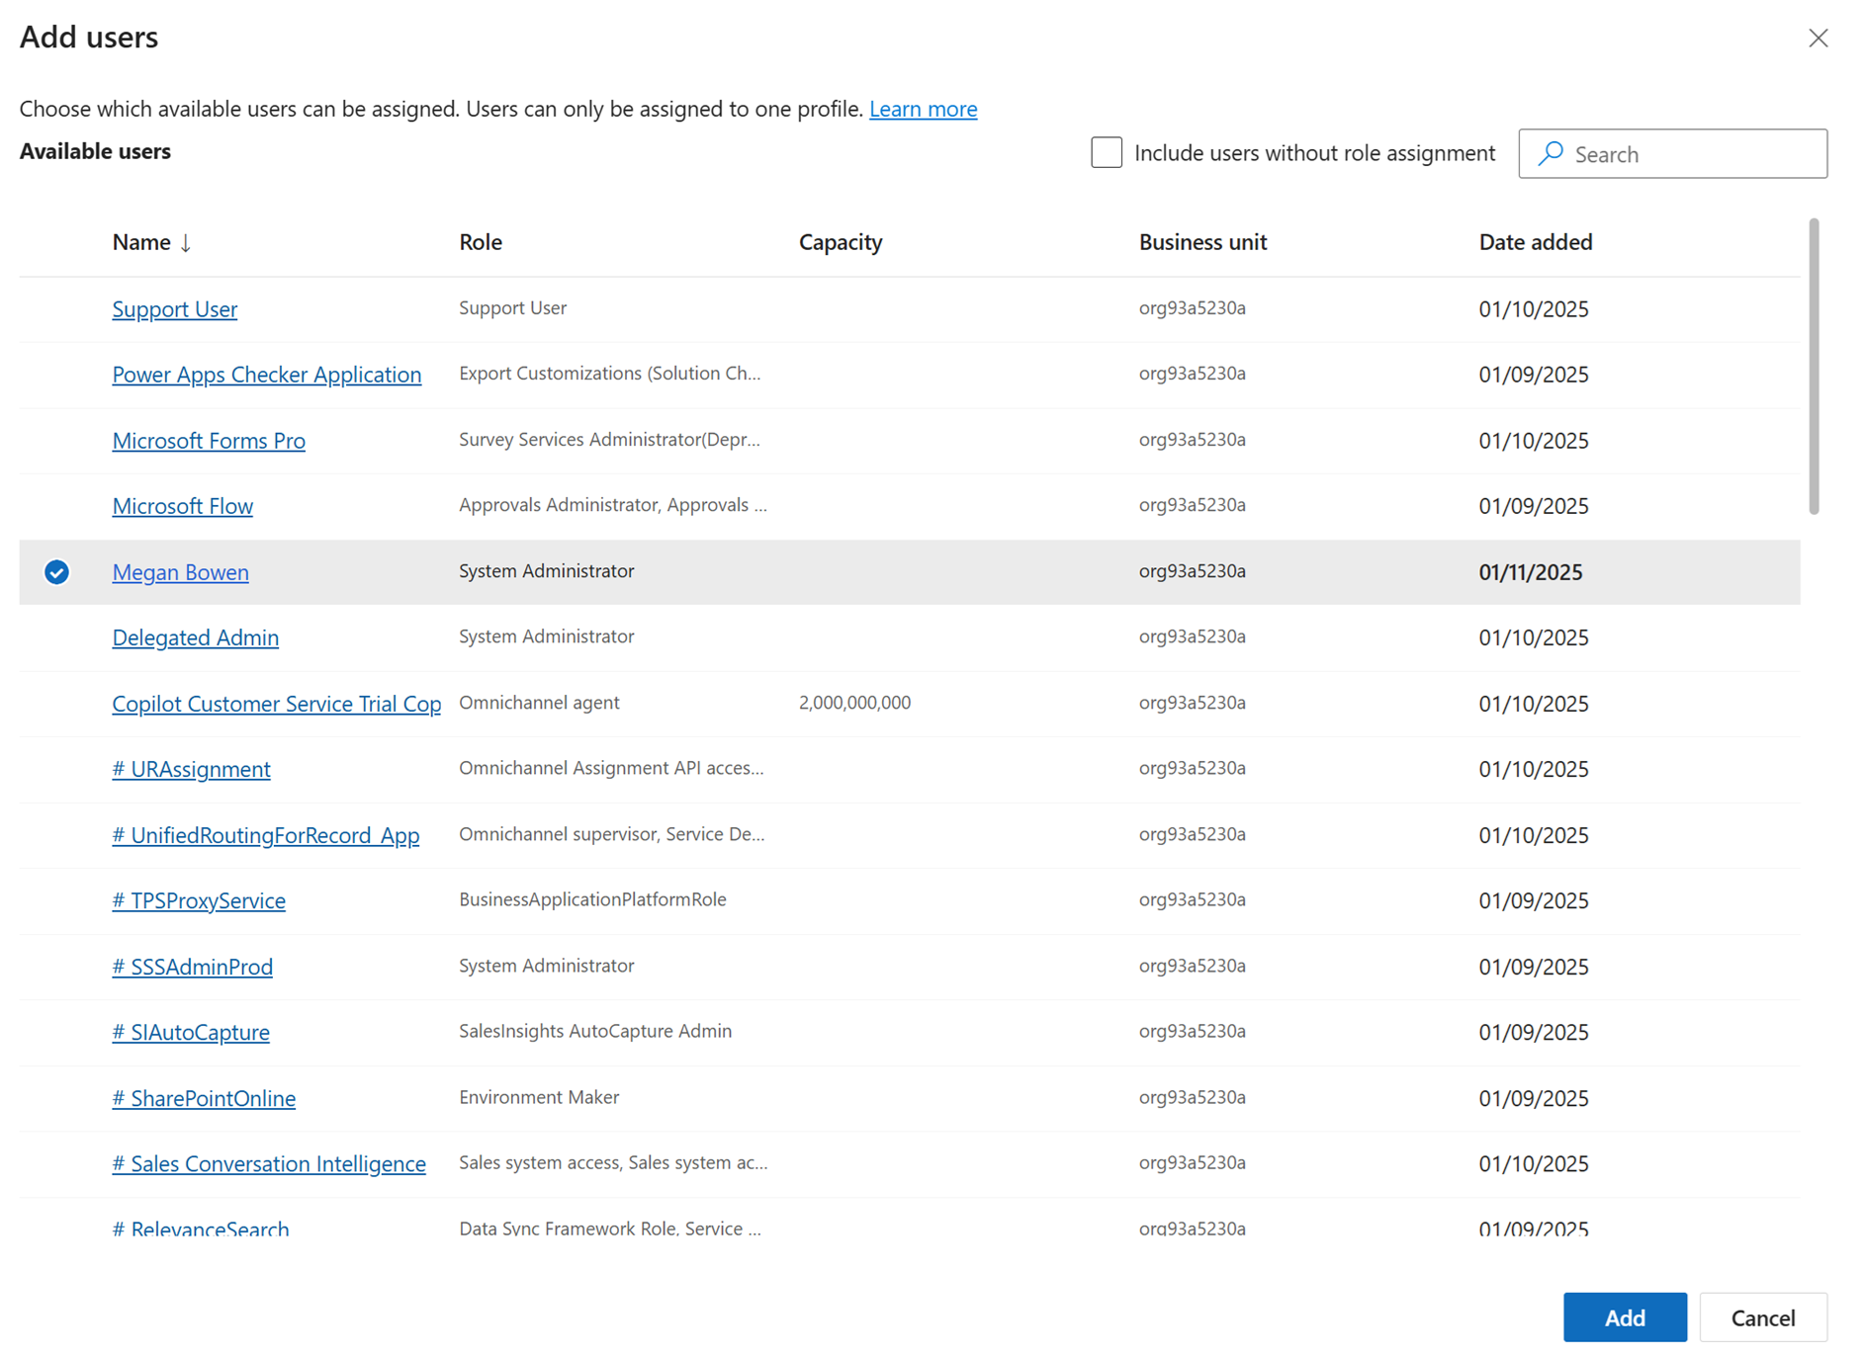

- 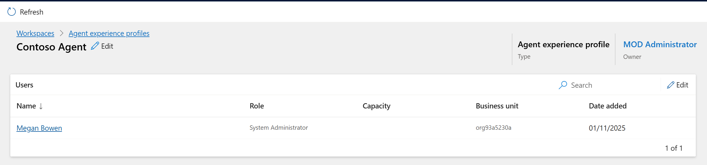
- In the Productivity pane, select Turn on
- 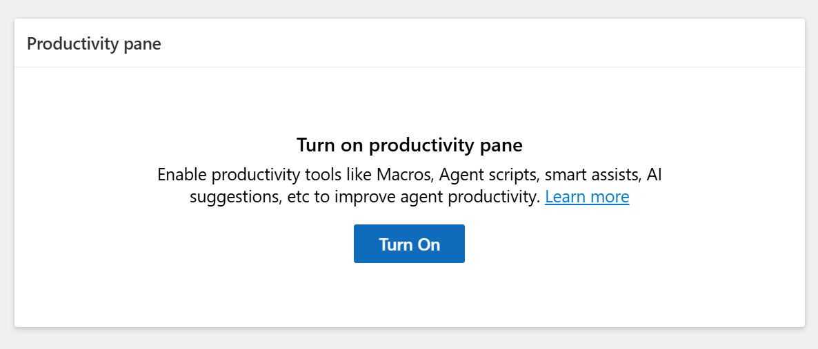
- Turn on the toggle against the option in the Productivity Pane as per the screenshot to enable it for the agent.
- Enable the available productivity tools that the agents can access when they work on their assigned tasks.
- Select Save and Close
- 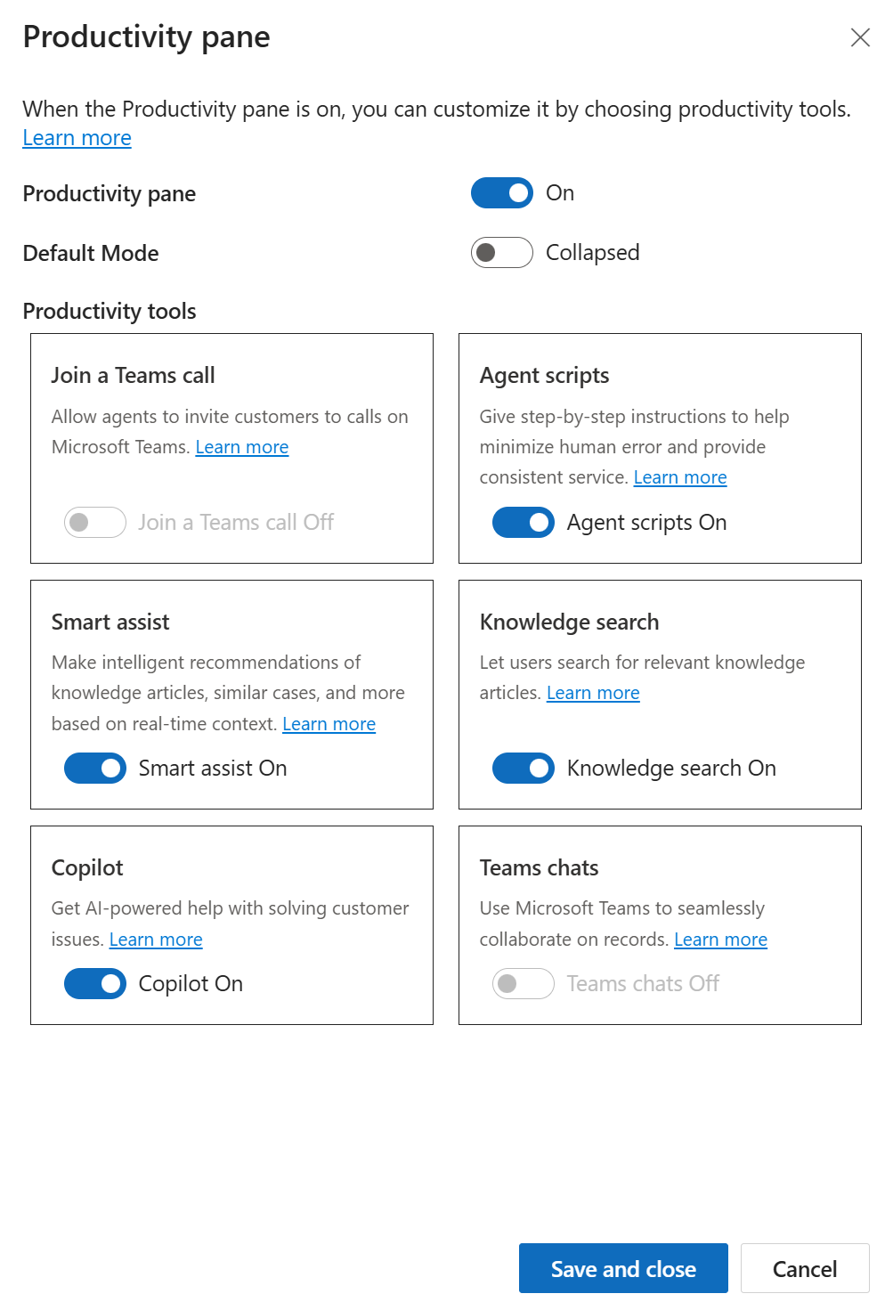
- 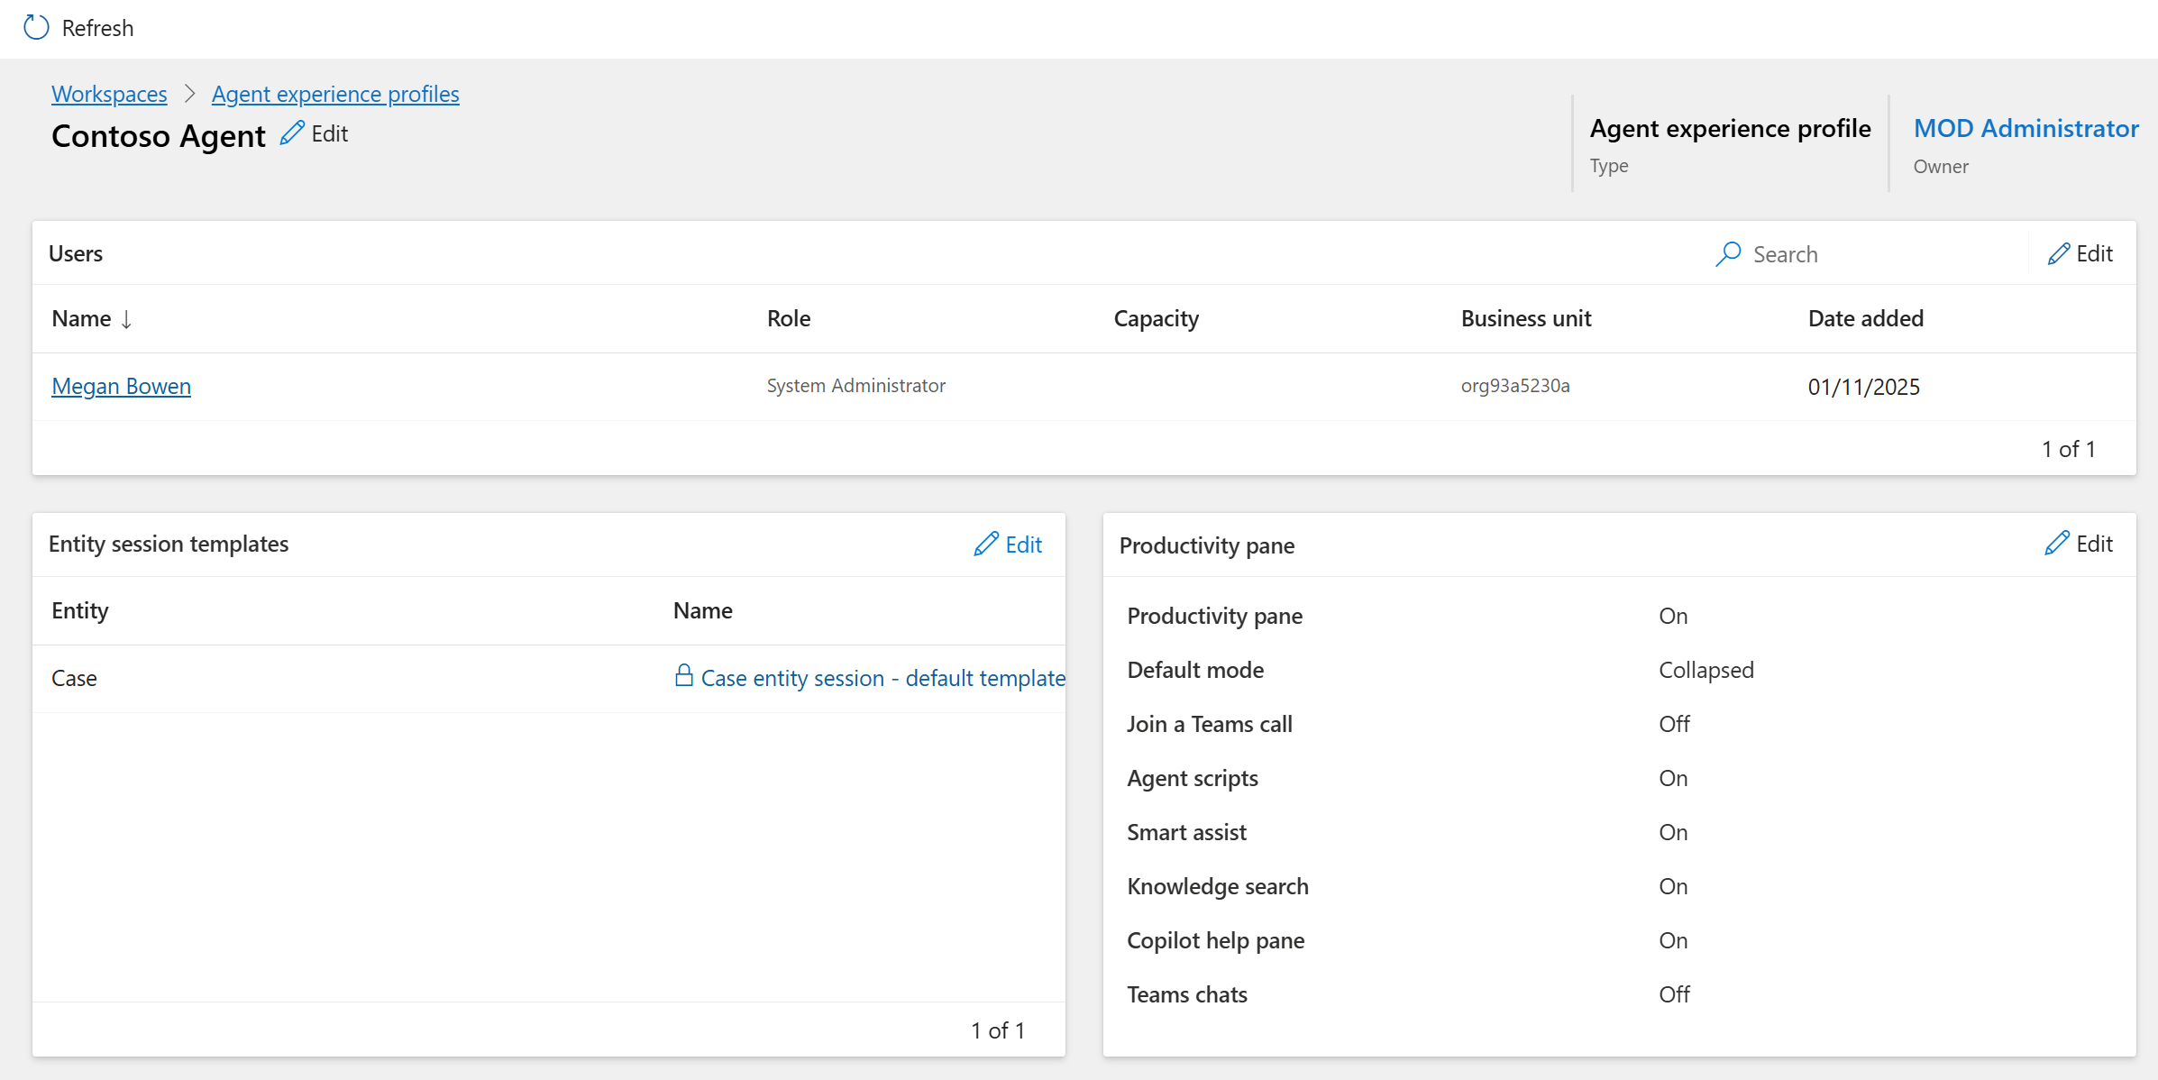

Conclusion
In this lab, you successfully created and configured an Experience Profile in Copilot Service. You created a custom profile for Contoso agents, added a user, assigned security roles, and enabled productivity features. This configuration ensures agents receive a tailored workspace with the tools needed for efficient case handling and improved service performance.

